|  |
| --- |
| Report on code repository use for ISD |
| Your name and student number |
|  |
|  |
|  |

Report on code repository use for ISD

Your name and student number

Contents

Introduction 2

Demonstration of creation of version control repository 3

Demonstration of code repository use 4

Conclusions 5

References 6

# Introduction

In the introduction you should briefly explain what a code repository is and why you use a code repository. You can use the lecture slides (week 2) as well as external literature (articles, websites) with information about code repositories. You should keep the introduction concise, so at most two pages. An example for an external source is this website: <http://software.ac.uk/resources/guides/choosing-repository-your-software-project> which you need to reference with a reference like this: Chue Hong (2015)

# Demonstration of creation of version control repository

In this section you briefly describe how you have created your code repository. You can use the relevant lecture slides (week 2) as well as any screenshots you may have taken. You can also add Screenshots of your repository/ies (online, or locale, depending of what repository you decided to use).

For example: A screenshot of your Git-profile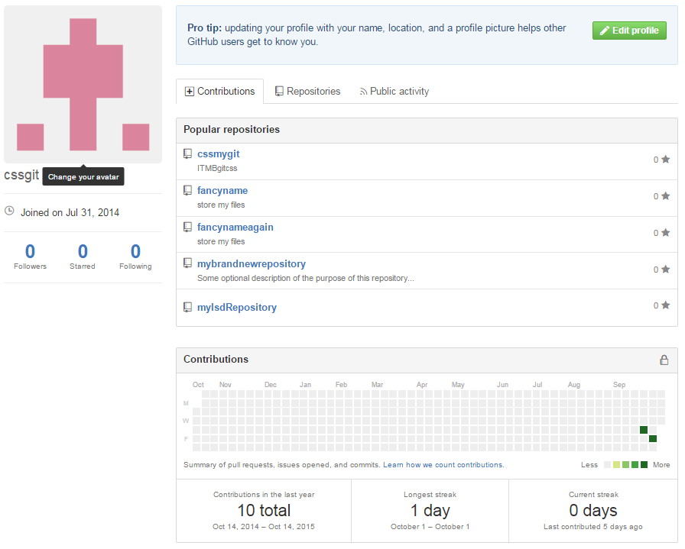

A selected repository screenshot

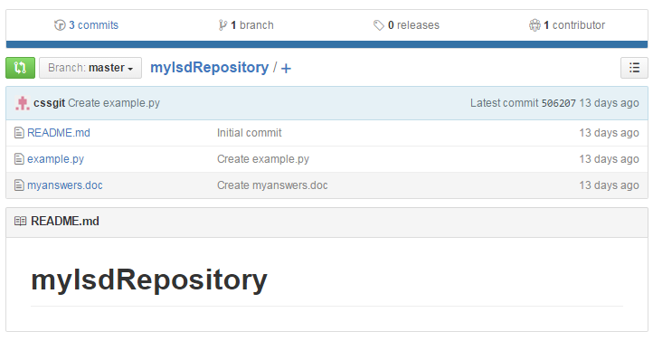

# Demonstration of code repository use

In this section you document the use of your code repository, mainly by showing evidence of commits to your repository. This can be done with screenshots (see below) or by providing log texts from your repository.

An overview screenshot of commits to the repository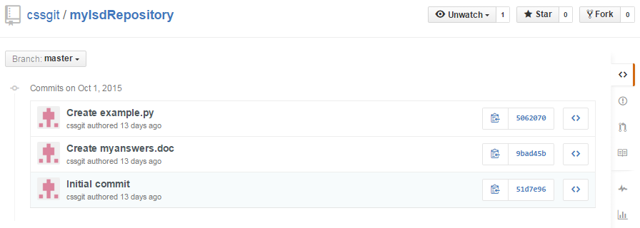

# Conclusions

In this section you briefly conclude on your experience (so far) on working with the code repository. For example, was it easy to set up, is it a hassle to use (if so, why?) or is it okay, what went particularly good? Again, keep the section concise, at max a page.

# References

As you are encouraged to use (at least) one external literature source (or website) to talk about what code repositories are and why they are useful, you need to give a reference to this (these) source(s).

The Reference for the example source is:

Chue Hong (2015): Neil Chue Hong: Choosing a repository for your software project, web article, 2015, available at: <http://software.ac.uk/resources/guides/choosing-repository-your-software-project>

Last visited: 12.10.2015